**Problem Statement and Application Scope:**  
1. First, here for this project, there are 2 types of users. One is “admin” who can log in as Admin and can delete or add editor and the other one is “editor”. Only active editor can log in as Editor and can post only articles. All types of users will land on the ‘login’ page first. There is only one option at the top and that is login. Users need to email, password and role value to log in. Otherwise, it will land on this login page if the user does not provide the right information.

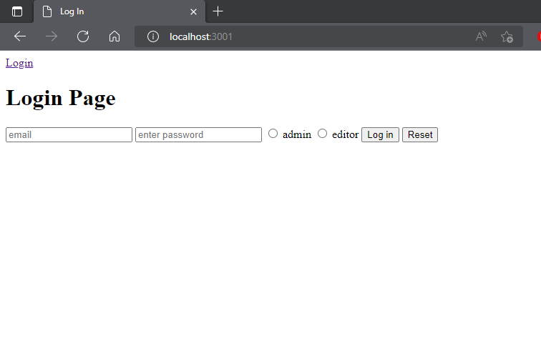

Figure: Login Page View

2. When the admin successfully logs in, the admin will land on the user page and see 2 options at the top. One is ‘User’ and the other is ‘Log out’. And in the bottom, the admin can see the user list. On this ‘user’ page, the admin can add a user and delete a user. Admin can add “active editor”, “inactive editor”, as well as “admin” but can not delete the “admin”. Admin can only add one “active editor”. If admin want to add more “active editor”, it will not add. By clicking the logout option, the admin will log out and go to the log-in page. Admin can only add one email as user email. So there is no duplicate email in user email.

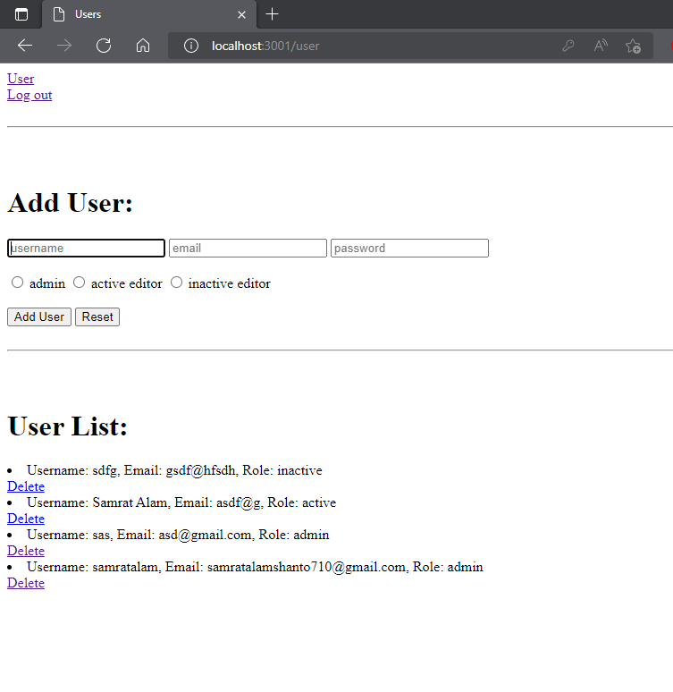

Figure: User Page View

3. When the active editor logged in, an editor will land on the ‘article’ page. The editor will see 2 options at the top. One is ‘Articles’ and the other one is ‘Log out’. An editor can post and delete articles. And articles will show at the bottom of the page. The article which will add last, will show at the top. By clicking the logout option, an editor will log out and go to the ‘log in’ page

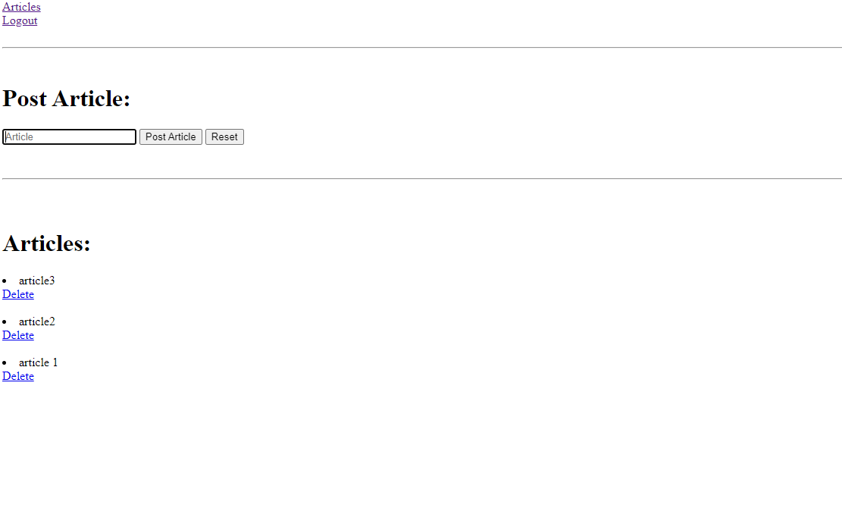

Figure: Article Page View

**Schema Diagram:**

1. I use mongoDB. In the mongoDB, the user password will store as hased password using bcrypt NPM package.

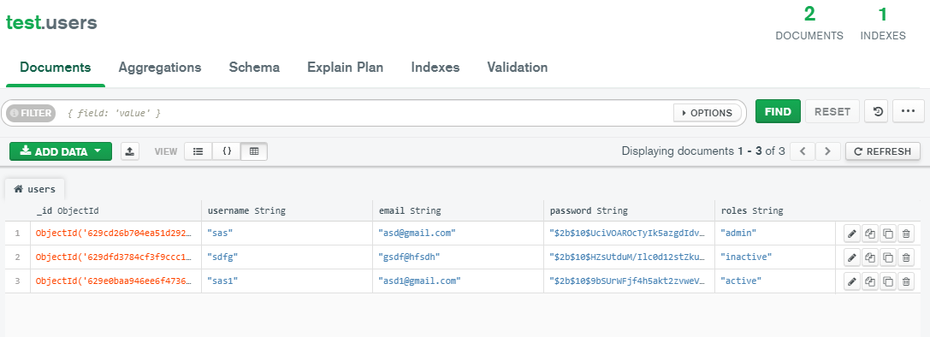

Figure: User Collection

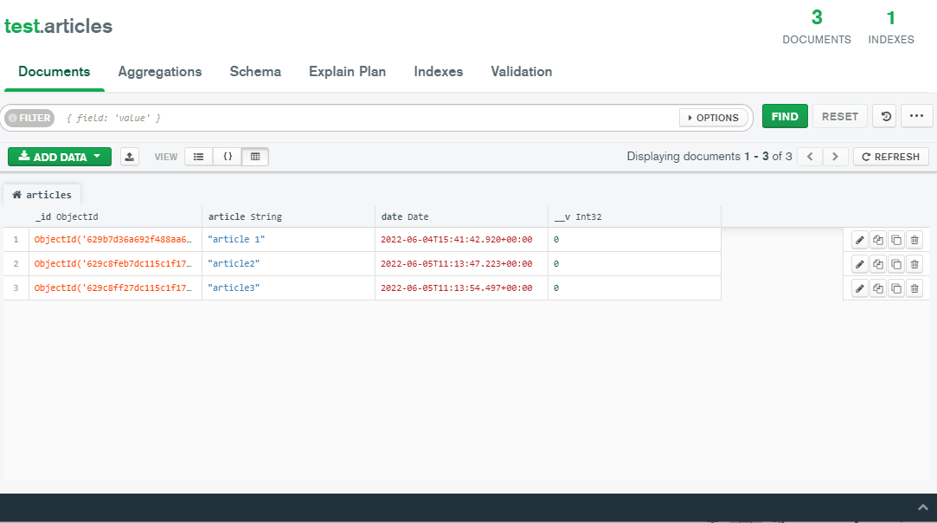

Figure: Article Collection

2. Database Schema:

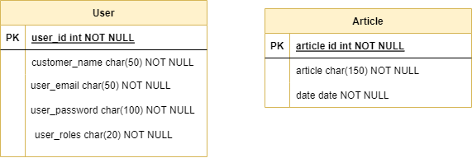

**GitHub Repo**

1. Repo Link**:** [samratalamshanto/Projects (github.com)](https://github.com/samratalamshanto/Projects)
2. Deploy Link: [Log In (newspaper-projects.herokuapp.com)](https://newspaper-projects.herokuapp.com/)

**Data stored:**

For admin:

Email: asd@gmail.com,

password: 123,

Role: “admin”

For Active editor:

Email: asd1@gmail.com,

password: 123,

Role: “editor”

**(using the admin and editor data, anyone can add or delete user, post or delete article)**